Statement
UPDATE Location
SET LocName = 'Gate'
WHERE LocNo= 'L107';

Before (9 rows)
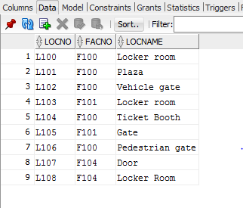

After(Row updated)
